**DAILY ONLINE ACTIVITIES SUMMARY**

|  |  |  |  |  |  |  |  |  |
| --- | --- | --- | --- | --- | --- | --- | --- | --- |
| **Date:** | **03/06/2020** | | | | | **Name:** | **NAIPUNYA VINOD NAIK** | |
| **Sem & Sec** | **IV SEM & A SECTION** | | | | | **USN:** | **4AL18CS050** | |
| **Online Test Summary** | | | | | | | | |
| **Subject** | | **OBJECT ORIENTED CONCEPTS** | | | | | | |
| **Max. Marks** | | **30** | | **Score** | | | **20** | |
| **Certification Course Summary** | | | | | | | | |
| **Course** | **INTRODUCTION TO DIGITAL MARKETING** | | | | | | | |
| **Certificate Provider** | | | **GOOGLE** | | **Duration** | | | **40 HRS** |
| **Coding Challenges** | | | | | | | | |
| **Problem Statement:1)** Write a code segment in java to swap two numbers using call by object reference.  2) [Write a Java program to find Last Digit of a^b (a to the power b) for Large Numbers](https://github.com/orgs/alvas-education-foundation/teams/2nd-year/discussions/97).  3) [Write a function that takes a two-digit number and determines if it's the largest of two possible digit swaps.](https://github.com/orgs/alvas-education-foundation/teams/2nd-year/discussions/96) | | | | | | | | |
| **Status: EXECUTED** | | | | | | | | |
| **Uploaded the report in Github** | | | | | **YES** | | | |
| **If yes Repository name** | | | | | <https://github.com/naipunya-naik/lockdown-coding/blob/master/JAVA%20CODING/Swapping_03-06-2020.java>  <https://github.com/naipunya-naik/lockdown-coding/blob/master/JAVA%20CODING/largest%20a%5Eb_03-06-2020.java>  <https://github.com/naipunya-naik/lockdown-coding/blob/master/C%2B%2B%20CODING/LARGESTSWAP_03-06-2020.cpp> | | | |
| **Uploaded the report in slack** | | | | | **YES** | | | |

Online Test Details: (Attach the snapshot and briefly write the report for the same).

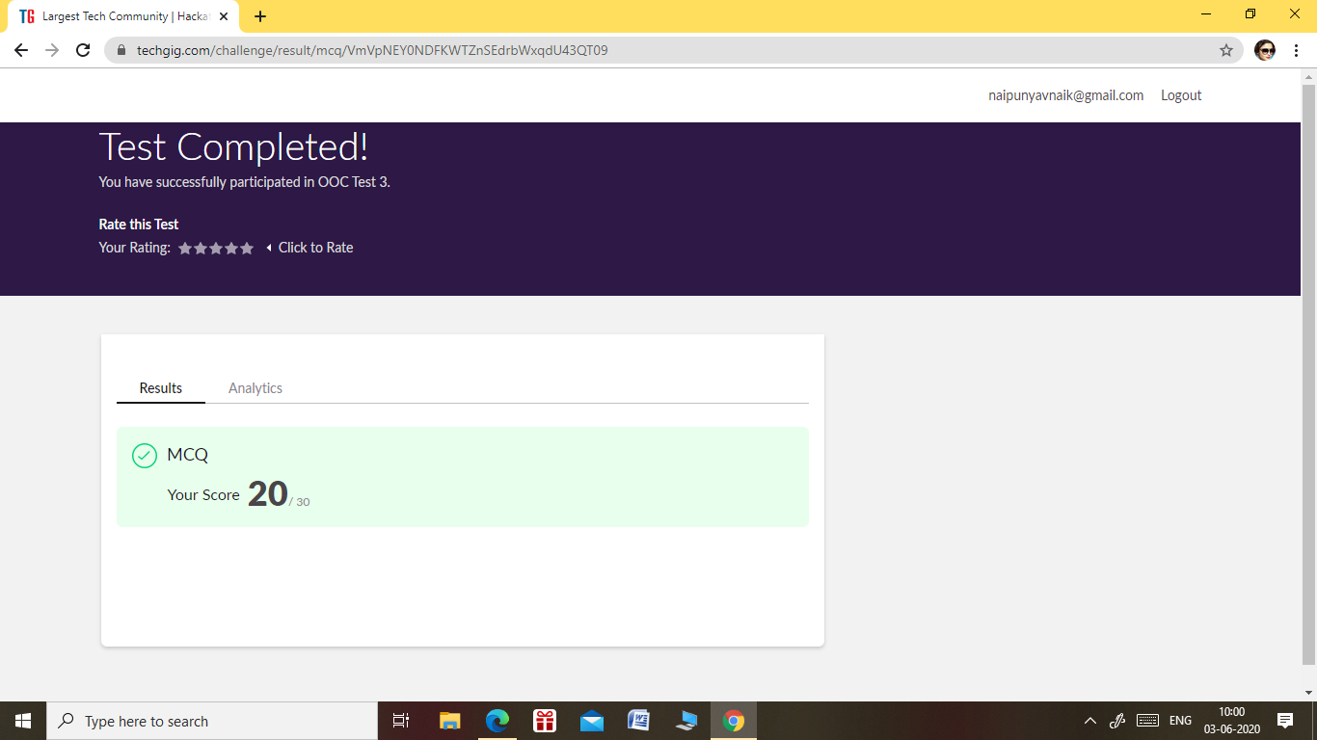

* THE 3RD I.A TEST OF SUBJECT OBJECT ORIENTED CONCEPTS WAS CONDUCTED ON 03 JUNE 2020.
* SUBECT:- OBJECT ORIENTED CONCEPTS
* SYLLABUS:- MODULE 2 AND MODULE 3
* START TIME:- 9.15 AM
* END TIME:- 10.00 AM
* DURATION:- 45 MIN
* NO.OF QUESTIONS:- 30
* EACH QUESTION COMPRISED ONE MARK.

Certification Course Details: (Attach the snapshot and briefly write the report for the same).

CERTIFICATION COURSE NAME:- INTRODUCTION TO DIGITAL MARKETING

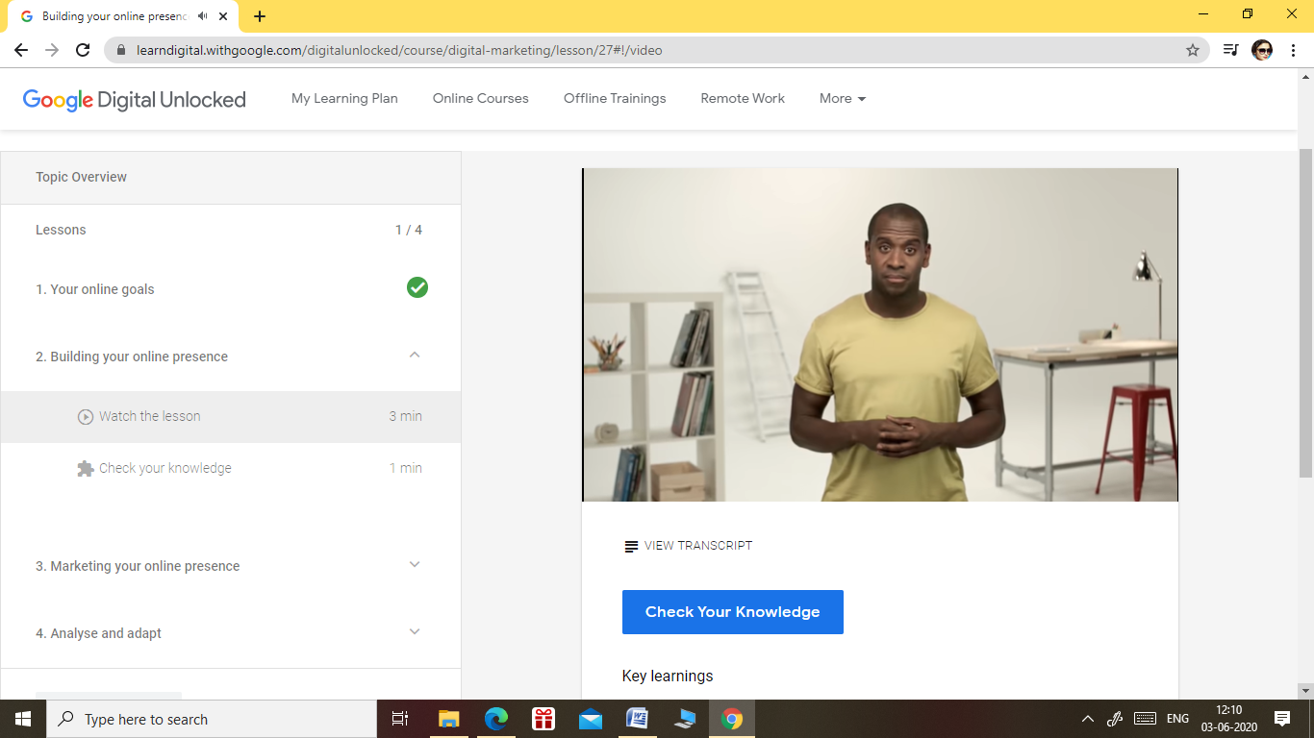

TOPICS LEARNT ON 03 JUNE 2020:-

* YOUR ONLINE GOALS
* BUILDING YOUR ONLINE PRESENCE
* MARKETING YOUR ONLINE PRESENCE
* ANALYSE AND ADOPT

Coding Challenges Details: (Attach the snapshot and briefly write the report for the same)

PROBLEM STATEMENT 1) [Write a function that takes a two-digit number and determines if it's the largest of two possible digit swaps.](https://github.com/orgs/alvas-education-foundation/teams/2nd-year/discussions/96)

|  |
| --- |
| To illustrate: largestSwap(27) ➞ false largestSwap(43) ➞ true If 27 is our input, we should return false because swapping the digits gives us 72, and 72 > 27. On the other hand, swapping 43 gives us 34, and 43 > 34. Examples largestSwap(14) ➞ false largestSwap(53) ➞ true largestSwap(99) ➞ true |

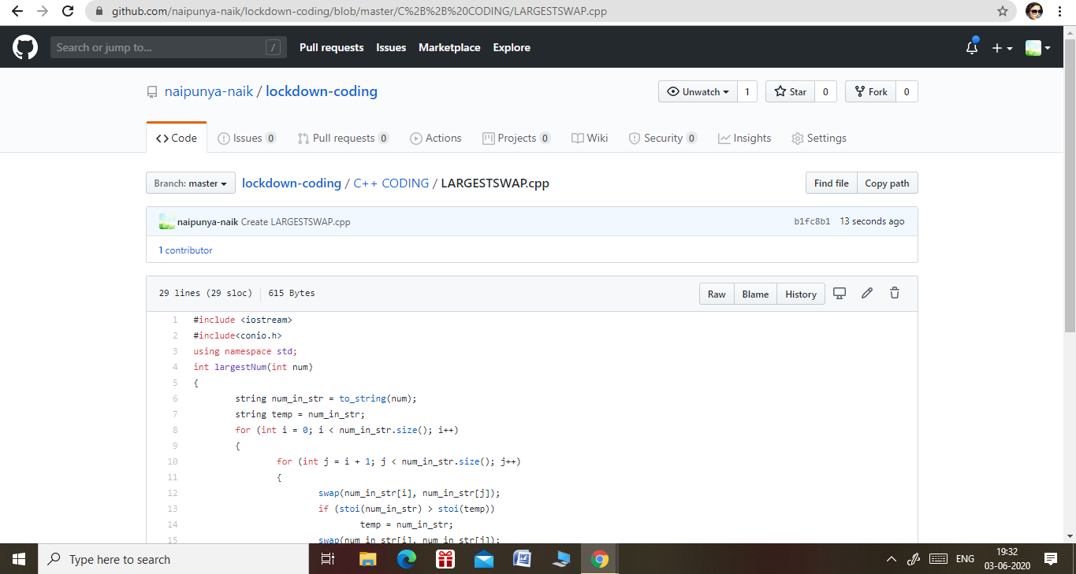

GITHUB REPOSITORY LINK:-

<https://github.com/naipunya-naik/lockdown-coding/tree/master/C%2B%2B%20CODING>

PROBLEM STATEMENT 2)

Top of Form

Bottom of Form

Top of Form

Bottom of Form

[Write a Java program to find Last Digit of a^b (a to the power b) for Large Numbers](https://github.com/orgs/alvas-education-foundation/teams/2nd-year/discussions/97)

|  |
| --- |
| You are given two integer numbers, the base a (number of digits d, such that 1 <= d <= 1000) and the index b (0 <= b <= 922*10^15). You have to find the last digit of a^b.  Examples:  Input : 3 10 Output : 9  Input : 6 2 Output : 6  Algorithm Algorithm :   1. Since number are very large we store them as a string. 2. Take last digit in base a. 3. Now calculate b%4. Here b is very large. -> If b%4==0 that means b is completely divisible by 4, so our exponent now will be exp = 4 because by multiplying number 4 times, we get the last digit according to cycle table in above diagram. ->If b%4!=0 that means b is not completely divisible by 4, so our exponent now will be exp=b%4 because by multiplying number exponent times, we get the last digit according to cycle table in above diagram. -> Now calculate digit = pow( last_digit_in_base, exp ). ->Last digit of a^b will be ldigit%10. |

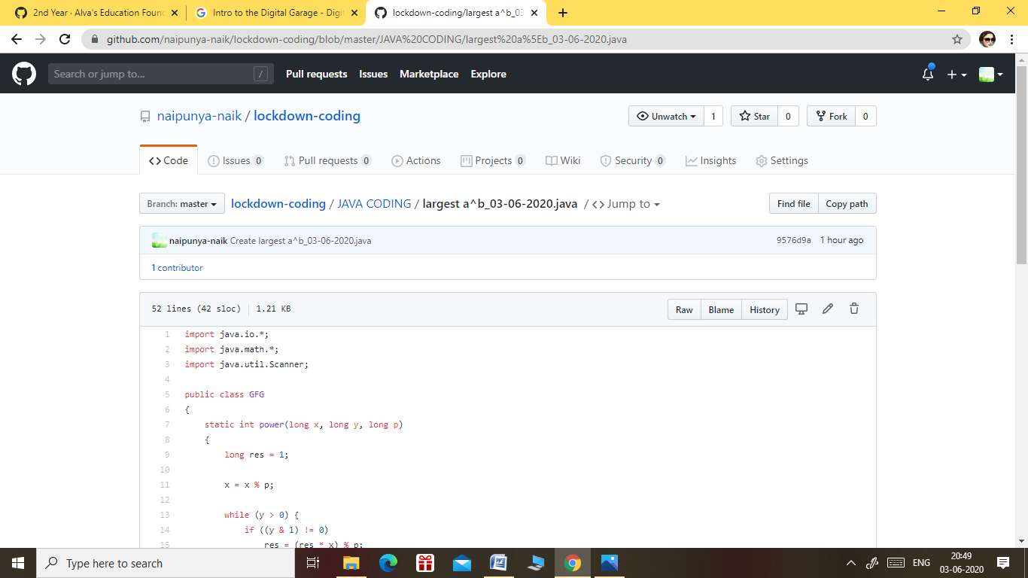

GITHUB REPOSITORY LINK:-

<https://github.com/naipunya-naik/lockdown-coding/blob/master/JAVA%20CODING/largest%20a%5Eb_03-06-2020.java>

3) Write a code segment in java to swap two numbers using call by object reference.

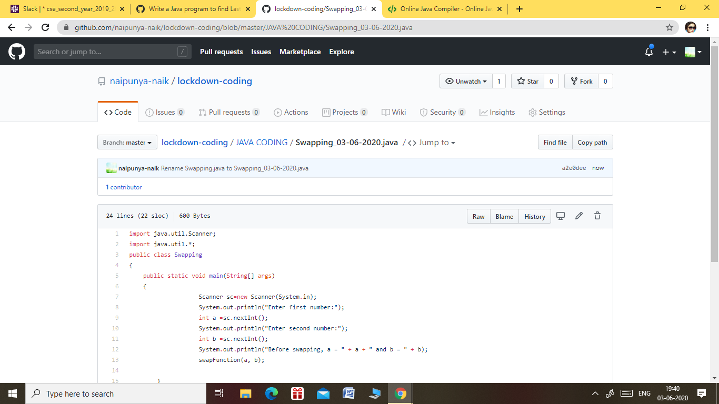

GITHUB REPOSITORY LINK:-

<https://github.com/naipunya-naik/lockdown-coding/blob/master/JAVA%20CODING/Swapping_03-06-2020.java>